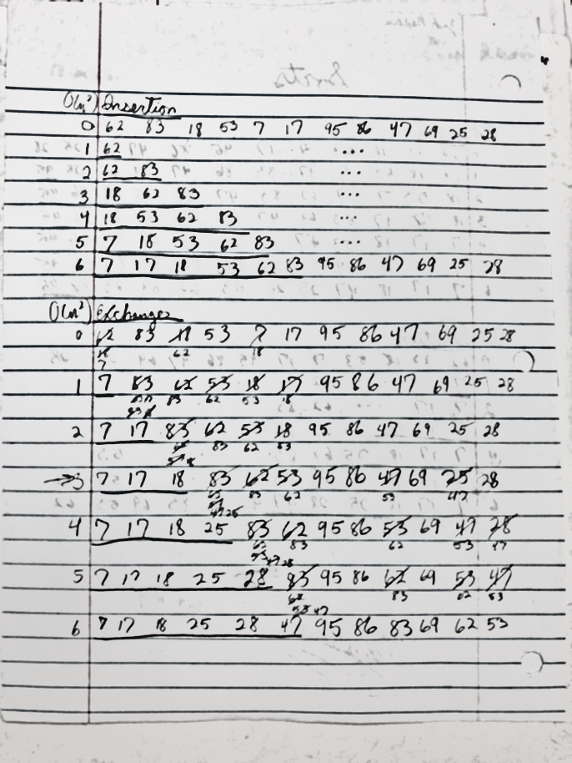**CS 2315: Exam 4 Review**

*Sorts & Searches*

|  |  |  |
| --- | --- | --- |
| Name | Big-O | Best Time |
| Bubble Sort | N2 | N |
| Selection Sort | N2 | - |
| Exchange Sort | N2 | - |
| Insertion Sort | N2 | N |
| Shell Sort | N3/2 | - |
| Merge Sort | NlogN | - |
| Bucket Sort | N | - |
| Linear Search | N | C |
| Binary Search | logN | C |

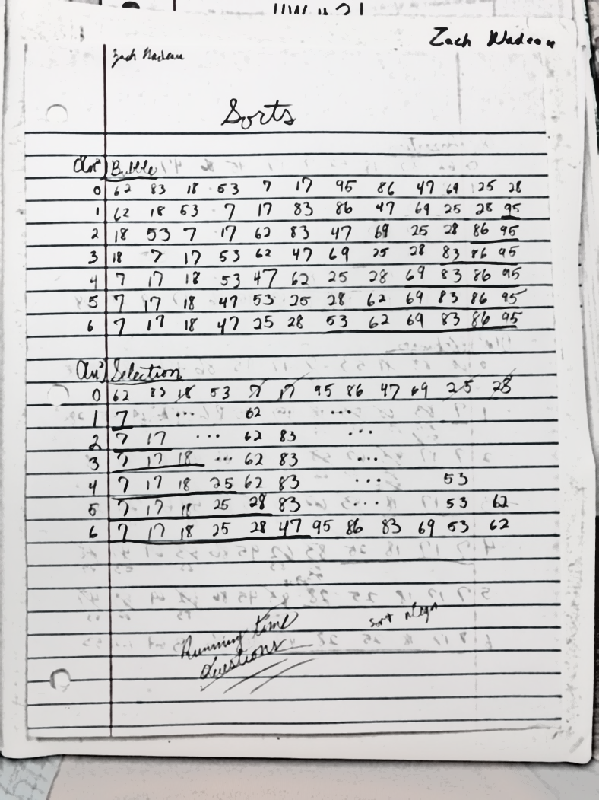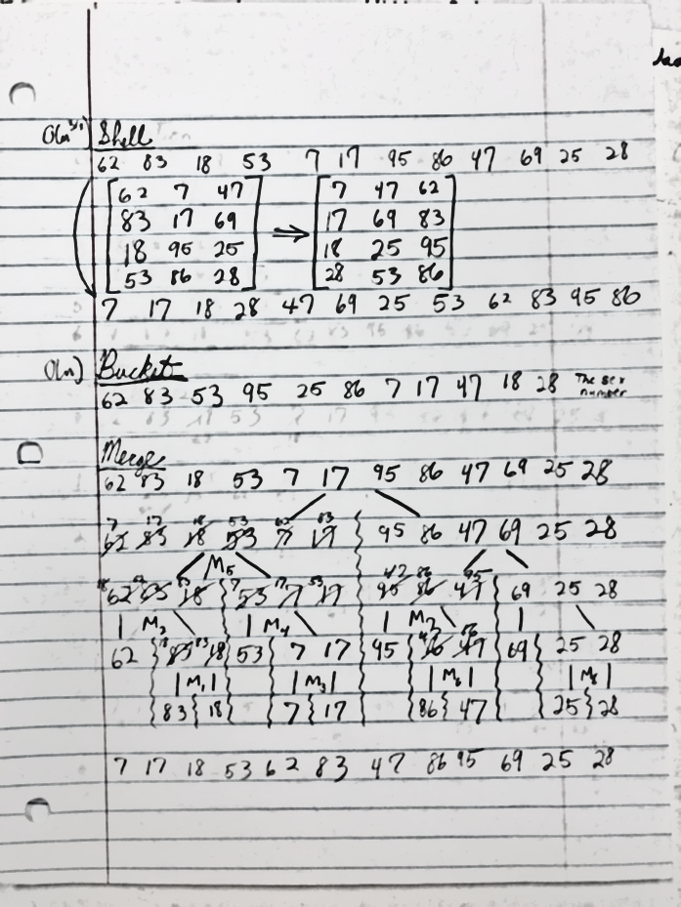*Vector/miniVector*

|  |  |
| --- | --- |
| Name | Big-O |
| *operator= | N |
| *operator[] | C |
| at | C |
| front/*back | C |
| data | C |
| iterators | C |
| *empty | C |
| *size | C |
| reserve | **N |
| *capacity | C |
| shrink_to_fit | N |
| clear | C |
| *insert | N |
| *erase | N |
| *push_back | C |
| *pop_back | C |
| resize | N |
| comparisons | N |

*Contained in miniVector

**Amortized Constant

*Matrix*

|  |  |
| --- | --- |
| Name | Big-O |
| operator[] | C |
| rows/cols | C |
| resize | N2 |